**CONSTRUCTION OF A DIGITAL VARIABLE POWER SUPPLY (1 to 30 volt) WITH USB PORT**

**presented by**

**salihu abdullahi**

**st/phy/hnd/21/001**

**A PROPOSAL SUBMITTED to the department of applied physics, federal polytechnic, mubi**

**supervised by**

**mr. sabo tantaso**

**june, 2023**

**Chapter one**

**INTRODUCTION**

**1.1 Background of the Study**

Development in the field of electronic have provided different technological approach used for upgrading and improving the standard DC voltages, communication instrumentation control etc. electronics perhaps more than any other field of technology, has enjoyed an explosive development. Generally, In electronics all electrical instrument and circuit require a source of direct current (DC) power before they operates, it Is either from a battery or a AC source (Hoftman, 2013).

According to Theraja and Theraja (2008) opines that most of electronic devices ad circuit require a d.c source for their operation. Dry cells and battery are one form of d.c source. Those type of dc source voltages are low; they need frequent replacement and are expensive as compared to conventional d.c. power supply (Adeite & Osemelikilali, 1996).

A power supplies have a power input which receives energy from the energy source. and a power output that delivers energy to the load. Most power supply the power input and output consist of electrical connectors or hardware circuit connection (John, 2020). The circuit mainly compose of the input transformer which will be used to transform the incoming line voltage down to the required level for the power supply, the power supply rectifier covert the AC voltage to DC voltage either halfwave or full wave, the addition of a reservoir capacitor here fills In the troughs in the wave form, enabling the next stage of power supply to operate, large value and capacitor are to be used in this stage (Robert & Louis 2004). The voltage adjuster of the power supply takes the smoothed voltage and use a variable integrated circuit (IC) and potentiometer to provide a variable regulated output virtually regardless of the output current and any minor fluctuation in the input level (Study, 2014).

**1.2 Statement of the Problem**

For prototyping and hobbyist, appliance or gadget with smaller voltage, they normally use battery as power source, instead of using batteries which have limited lifetime and fixed output.

A variable DC power supply can be used which is been implemented as digital variable power supply (the output voltage may be varies as required by the user and display in the screen.

**1.3 Aim and Objectives**

The aim is to construct a variable power supply to provide the required power load using an AC supply at the input and variable regulated power from 1 to 24v at the output terminal and display the value on screen, by earning the voltage adjuster known as potentiometer, it allows analog control and power supply output for maximum versatility and other objectives to be achieved are:

1. To observe the output to meet the requirement.
2. To use the device for more than one purpose power supply and USB.
3. To use less costly components and portability.

**1.4 Significance of the Study**

This project if completed will make it possible for researchers to have power supply to run different devices of higher or low value.

The project does not require any external measuring device such as multimeter and others because the quantity obtained is being displayed on the screen.

The project can be used in basic electricity laboratory and other laboratory where different D.C. voltage is required for practical.

The project can be used in electronic workshop by technician for repairs and maintenance of electronic devices

**1.5 Scope and Limitation**

The scope of the study is conversion of A.C. voltage to D.C. voltage to be displayed and it is limited to 1.5 to 30 volt.

**CHAPTER TWO**

**LITERATURE REVIEW**

**2.1 Review of Related Literature**

This chapter briefly bring the history of a D.C. power supply and a survey and analysis of what has been written on previously similar project or research.

Thomas Edison invented direct current in the late 1870s and in 1920s crude device were ffirst developed to serve as battery eliminators to power radios in both commercial and consumer market. The market for separate power supplies rise around 1929, where most radios manufactured include a built in power supply. The need for stand alone power supply remained relative from 1930 to 1940 (Charles, 2021). In the early 1950s and early 1960s power supply produced adopting may-Amp technology satisfy the application at this time vibrators converts and an automobile 12volt high voltage D.C. by mechanically switching (Frank, 2022).

Thermion (vacuum tube) diodes and solid state (semiconductor) diodes were developed separately, at approximately the same time, in the early 1900s, as radio receiver detectors. Until the 1950s vacuum tube diodes were more often used in radios because semiconductor alternatives (Cat’s Whiskers) were less stable, and because most receiving sets would have vacuum tubes for amplification that could easily have diodes included in the tube (for example the 12SQ7 double-diode triode), and vacuum tube rectifiers and gas-filled rectifiers handled some high voltage/high current rectification tasks beyond the capabilities of semiconductor diodes (such as selenium rectifiers) available at the time.

Battery-base, battery-linear and linear power supply those that the most common once (Green, 1995).

**2.2 Related Research**

**2.2.1 Unregulated d.c. power supply**

An unregulated D.C power supply is one whose D.C terminal is affected significantly by the amount of load the major setback of this type of power supply is as the load draws more current, the D.C terminal voltage becomes less (Theraja & Theraja, 2008).

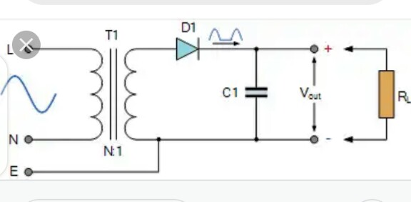

Figure 2.1: Unregulated power supply

**2.2.2 Voltage multipliers**

A voltage multiplier is a circuit which produce a greater D.C output than A.C input voltage to the rectifier. D.C voltage multiplier are required in application when it is necessary to have high voltage with low current as for electron accelerating purpose in cathode ray tube. This type of D.C power Supply is not suitable for low voltage appliance (Paul & Simon, 2012).

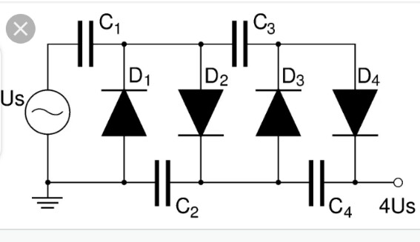

Figure 2.2: Voltage multiplier

**2.2.3 Battery base or battery**

Battery base power is a third type of power supply and is essentially a mobile energy storage unit with fixed output while battery consist of a electro chemical cell connected either in series or parallel is a power generating devices which is capable of converting stored chemical into electrical energy.



Figure 2.3: Battery base

**2.2.4 Transformer**

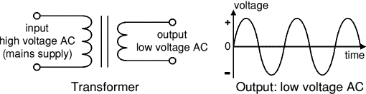

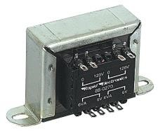

Figure 2.4: Transformer

A Transformer is an equipment used either for raising or lowering the voltage of an ac supply with a corresponding decrease and increase in current. It essentially consist of two windings primary and secondary

N1 = no. of turns in primary coil

N2 = no. of turns in secondary coil

N1< N2 = Step-up transformer

N1> N2 = Step-down transformer

Transformers convert AC electricity from one voltage to another with little loss of power. Transformers work only with AC and this is one of the reasons why mains electricity is AC.

Step-up transformers increase voltage, step-down transformers reduce voltage. Most power supplies use a step-down transformer to reduce the dangerously high mains voltage (230v) to safer low voltage.

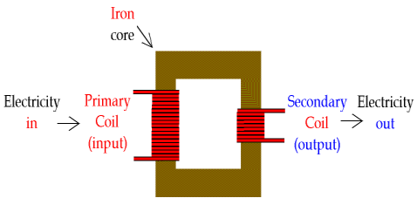

Figure 2.5: Transformers and their symbol

The input coil is called the primary and the output coil is called the secondary. There is no electrical connection between the two coils, instead they are linked by an alternating magnetic field created in the soft-iron core of the transformer. The two lines in the middle of the circuit symbol represent the core.

Transformers waste very little power so the power out is (almost) equal to the power in. Note that as voltage is stepped down current is stepped up.

The ratio of the number of turns on each coil, called the turn’s ratio, determines the ratio of the voltages. A step-down transformer has a large number of turns on its primary (input) coil which is connected to the high voltage mains supply, and a small number of turns on its secondary (output) coil to give a low output voltage.

# 2.2.5 Rectifier

There are several ways of connecting diodes to make a rectifier to convert AC to DC. The [bridge rectifier](http://www.kpsec.freeuk.com/powersup.htm#bridgerectifier) is the most important and it produces full-wave varying DC. A full-wave rectifier can also be made from just two diodes if a centre-tap transformer is used, but this method is rarely used now that diodes are cheaper. A [single diode](http://www.kpsec.freeuk.com/powersup.htm#singlediode) can be used as a rectifier but it only uses the positive (+) parts of the AC wave to produce half-wave varying DC.

## **2.2.6 Bridge Rectifier**

A bridge rectifier can be made using four individual diodes, but it is also available in special packages containing the four diodes required. It is called a full-wave rectifier because it uses all the AC wave (both positive and negative sections).

**The Positive Half-cycle**. During the positive half cycle of the supply,

diodes D1 and D2 conduct in series while diodes D3 and D4 are reverse biased and the current flows through the load as shown below.

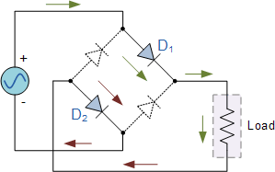

Output of Transformer

Figure 2.6: Positive Half cycle

The Negative Half-cycle During the negative half cycle of the supply, diodes D3 and D4 conduct in series, but diodes D1 and D2 switch “OFF” as they are now reverse biased. The current flowing through the load is the same direction as before.

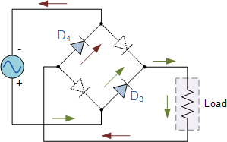

Output of

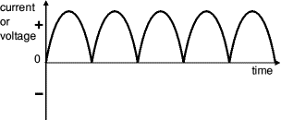

Figure 2.7: Resultant wave form

Hence, we can say that the bridge wave rectifier give the pulsating DC voltage which are not suitable for electronics circuit.

# 2.2.7 Smoothing (Filter)

Smoothing is performed by a large value [electrolytic capacitor](http://www.kpsec.freeuk.com/components/capac.htm#polarised) connected across the DC supply to act as a reservoir, supplying current to the output when the varying DC voltage from the rectifier is falling. The diagram shows the unsmoothed varying DC (dotted line) and the smoothed DC (solid line). The capacitor charges quickly near the peak of the varying DC, and then discharges as it supplies current to the output.

Smoothing is not perfect due to the capacitor voltage falling a little as it discharges, giving a small ripple voltage. For many circuits a ripple which is 10% of the supply voltage is satisfactory and the equation below gives the required value for the smoothing capacitor. A larger capacitor will give less ripple. The capacitor value must be doubled when smoothing half-wave DC

So, in this we concluded that the pulsating DC voltage is applied to the smoothing capacitor. This smoothing capacitor reduces the pulsations in the rectifier DC output voltage.

Output from the full wave bridge rectifier is fed to a LM317 regulator IC LM317 provides varied voltage from 1.2V to 35V. Reference voltage of 1.25 V is maintained at 220 ohm Resistor.

The LM317 Voltage Regulator is a 3-terminal [adjustable voltage regulator](http://www.learningaboutelectronics.com/Articles/What-is-an-adjustable-voltage-regulator) which can supply an output voltage adjustable from 1.2V to 35V. It can supply more than 1.5A of load current to a load.

**2.2.8 LM317 Pinout**

The LM317 Voltage Regulator has 3 pins. Below is the pinout:

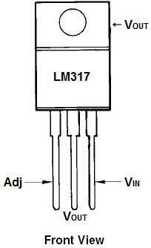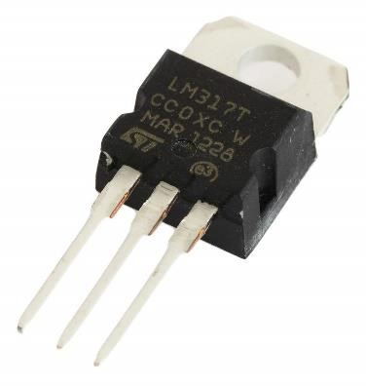

Figure 2.8: LM317 Pinout

Looking from the front of the voltage regulator, the first pin (on the left) is the Adjustable Pin, the middle is Vout, and the last pin(on the right) is VIN.

**VIN -** VIN is the pin which receives the incoming voltage which is to be regulated down to a specified voltage. For example, the input voltage pin can be fed 12V, which the regulator will regulate down to 10V. The input pin receives the incoming, unregulated voltage.

**Adjustable -** The Adjustable pin (Adj) is the pin which allows for adjustable voltage output. To adjust output, we swap out resistor R2 value for a different resistance. This creates adjustable voltages.

**VOUT -** VOUT  is the pin which outputs the regulated voltage. For example, the LM317 may receive 12V as the input and output a constant 10V as output.

**2.3 Digital variable D.C. power supply**

This project report is digital variable D.C power supply that ca deliver 1 to 30V regulated D.C. here we use a full wave rectifier along with a voltage regulator which gives suitable output, the output can be increased by using a pair of voltage divider resistor in which one resistance is variable to get variable output. Which is been read on the display unit. The major advantage of this power supply over others, it does not require an external measuring device to ascertain the output value. The D.C. voltage is regulated and is not fixed.

**CHAPTER THREE**

**3.1 Propose material and method**

The proposal material for the project are both active and passive electronic component. Most of the component to be used for this project are available, and the analog to digital converter is a module which will be connected to the constructed circuit.

**3.1.1 List of material**

|  |  |  |  |
| --- | --- | --- | --- |
|  | **Name** | **Value** | **Quantity** |
| 1 | Analog to Digital Converter | DT830D | 1 |
| 2 | Transformer step down | 240 50Hz 24 or 30V 3000 MA | 1 |
| 3 | Diode | IN 4001 | 6 |
| 4 | Capacitor | 2200uf 50V | 1 |
| 5 | Capacitor | 10uf 63V | 1 |
| 6 | Capacitor | 0.1uf | 1 |
| 7 | capacitor | 470uf 50V | 1 |
| 8 | Variable resistor | 10Kso | 1 |
| 9 | Resistor | 2.2kso 1watt | 1 |
| 10 | I.C | Lm 317 | 1 |
| 11 | Resistor | 1ks0 | 1 |
| 12 | LED | Red | 1 |
| 13 | Vero board | Copper lines | 1 |
| 14 | Connectors | Many | many |

**3.2 Method**

Electrical fabrication consists of electrical design that is making the construction of Vero board soldering and other connection, this project “digital variable DC power” will be constructed with transformer which will step down the AC to require value than the bridge rectifier, the rectifier signal is smoothed by the smoothing capacitor C1 when the supply is available it will be charged via diode and then to regulator.

After gathering the component required working out the strip board layout, having the circuit diagram laying the component as shown in the diagram. Placing the jumper where its requires, performing at the permanent soldering, connecting the external component such transformer analog to digital converter with the display unit to make it complicated.

**3.3 Expected Result**

|  |  |  |
| --- | --- | --- |
| **Circuit** | **Input** | **Output** |
| Transformer | 220VA.C | 30VA.C |
| Rectifier | 30V A.C | 32volt on load |
| Regulator | 30V D.C | 1 to 30 on load |
| Variable from 1 to 24 or 30volt D.C. display | | |

**3.3 Circuit Block Diagram**

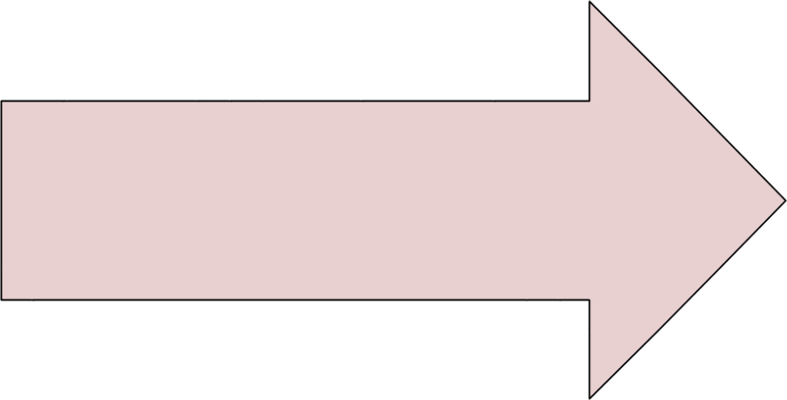

**AC supply**

**230**

**v/50hz**

**Transformer**

**(**

**step**

**-**

**down)**

**Diode**

**Rectifier**

**Filter**

**Circuit**

**Voltage**

**Regulator**

Figure 3.1: Circuit Block Diagram

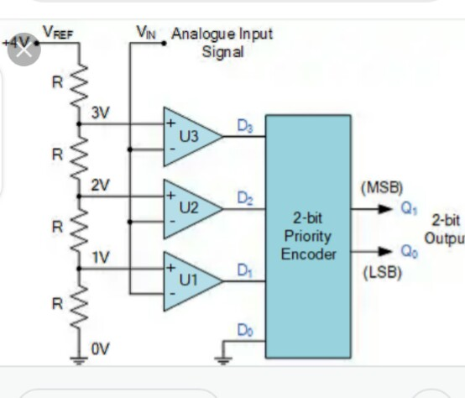

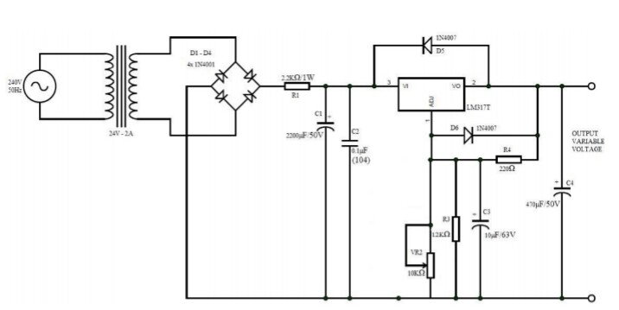

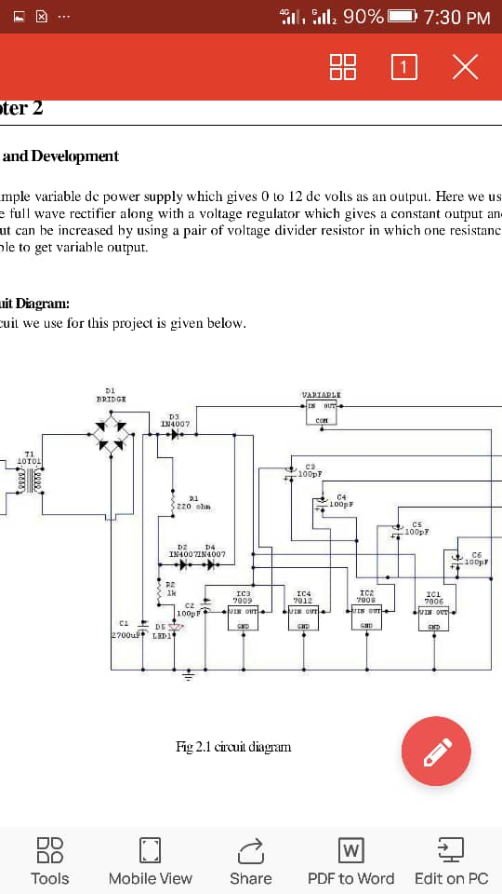

Figure 3.2: Circuit Diagram

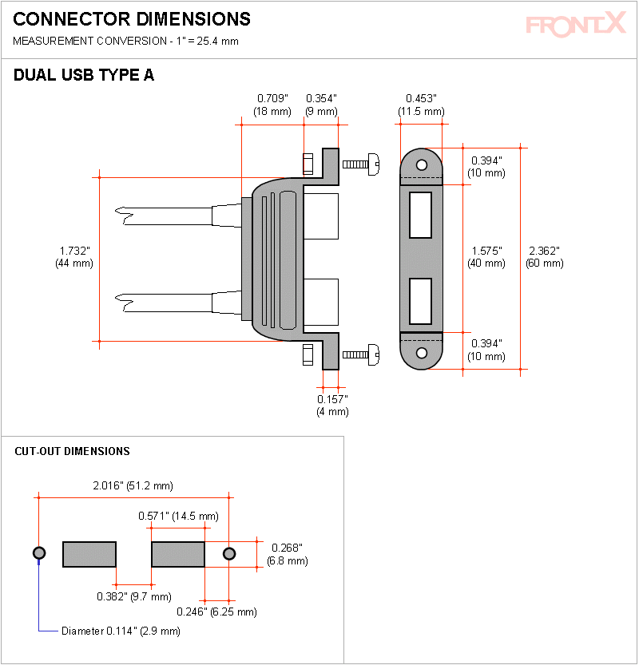

Figure 3.3: Dual USB Type A port

**REFERENCES**

A.K. & B.L. Theraja (2008). Electrical Electronics Technology

Adeife T.O & Osemekillali, O. (1996). *Electronic Engineering Fundamental voll*. Ademola printing press, Osogbo Osun State Nig.

Circuit Theory and Analysis by Abhijit Chakrabarti

Encyclopedia of Electronic Components by Charles Platt

Green, D.C (1995). *Electronic technology* 5th edition long man Scientific and technical long man group Ltd. Long burnt mull.

Hoftman, J. (2013). Power supplies and application. MacGraw Hill publisher, New York USA.

John, H. (2020). Power supplies electronics club, *International Journal of Advances in Applied Science Research, 4*(1):515-522.

Paul, S. & Simon, M. (2001). Practical Electronics for inventors

Robert, L. & Louis, N. (2004). *Electronic Device and Circuit Theory*. Eight Edition, Prentice Hall of India Private Limited, New-Delhi

Study, M. (20014). *Design of a 0 to 30v regulated d.c power supply*. Retrieved March 27th 2017: from http:/www.sturdymafia.org./ps/30_contents.htm

Theraja, B.L and Theraja, A. K. (2002). *A Textbook of Electrical Technology*. 23rd ed.s. Chand: New Delhi, India.

Wdwuard, I. (1995) *Electrical technology* 7th edition long man Singapore publisher P.T.O